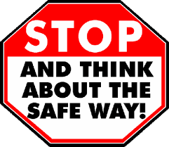
I keep my information safe; I don’t let people know
My name, address or number, or to which school I go
I never talk to strangers, if they’re not a real-life friend
No matter who they say they are, it could be just pretend
If I take a photo of a friend, I am always well aware
To ask if it’s ok with them, before I click and share
I’m always kind to others, in the playground and on screen
I never write or tell them things, that are hurtful, bad or mean
I always ask an adult, before I go online
If we look at things together, I know I will be fine
And if I ever see something, that makes me scared or sad
I tell an adult I can trust, and it won’t be so bad
So to all our super boys and girls, in St Patrick’s Primary School
Remember this wee rhyming poem, and use it as a tool
For keeping safe while learning, now and yes forever
That way you can do things right, while becoming very clever
We hope to see you very soon; we miss you every day
You are the best kids in the world, that’s what we all say

