St Patrick’s PS and NU, Loughguile
Eco-Code

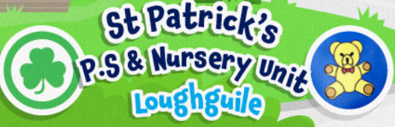

G - Gardening and growing our own food
L - Littering must stop
O - Our world matters
B - Biodegradable is best
A - Always reduce, reuse, recycle
L - Look after our environment
