Curriculum Sept/Oct 2022

Accelerated Reading P4 – P7

Mathletics P1 – P7

Catch-Up Numeracy

Reading Support P1/P3

Engage III Programme

St. Patrick’s Core Kids Summer Camp August 2022

The summer camp took place in August, members of staff had been trained by the Core Kids team to deliver different activities. The sun shone throughout the three days and the pupils and staff enjoyed every minute of it!! We look forward to next year!!





Staff Training

Whole staff Child Protection training

Core Kids online training

Fresh Little Minds

Catch Up Maths

After School/ In school clubs

P1 – P7 Hurling/Camogie in school with Dominic (Sept – Dec)

P6 – Swimming in Joey Dunlop leisure Centre

P7- Eco Garden club (Fridays) – in school

P6 – Multi sports Sept – Oct – after school

P7- Transfer Club Sept – Mid Nov – after school

Healthy Happy Minds – pupil counselling

St. Patricks is one of the very fortunate schools to have been able to employ the services of a trained counsellor. This has allowed the school to offer 1:1 counselling to individuals and small group support also.

Pupil Voice

This school year in St. Patrick’s we have extended the concept of student voice further.

We now have:

P6 Digital Leaders

P4 – P7 School Councillors

P7 Reading Buddies

P7 Eco Council

Already this is proving to be an excellent addition to the school



Parent/Teacher Interview

The Parent/Teacher interviews took place during the week of 22nd October. Many thanks to all the parents for their participation in the meetings. The teachers were delighted to have the opportunity to meet with the parents

Mobile Library

We are delighted to have the return of the Mobile Library Service to St. Patrick’s.

Tempest School Photographs

School photographs took place on 27th October. Nursery, P1 and P7 class photos will be taken in the next term



Halloween Dress Up

The pupils enjoyed dressing up in fantastic costumes for Halloween on Friday 28th October and they all enjoyed a “spooky” fun Halloween disco!

Whole School Mass

The beginning of school year mass took place on Friday 21st October





St. Patrick’s Primary School and Nursery Unit

Where We Play Learn and Grow Together and are the Best That We Can Be

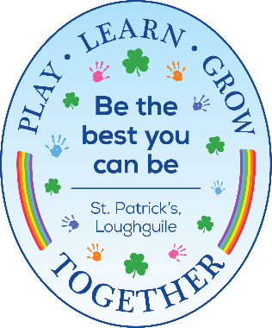

[](https://www.google.co.uk/url?sa=i&rct=j&q=&esrc=s&source=images&cd=&cad=rja&uact=8&ved=0ahUKEwjv3-Os3JnUAhWJI8AKHdFvApIQjRwIBw&url=https://it.pinterest.com/pin/102105116521590391/&psig=AFQjCNEy-i2srZohoce1KHHqQn6Bg6jrdA&ust=1496305990805993)